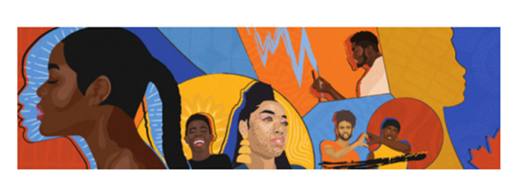

MARLANT DVMAG Black History Month Quiz 2022

Please submit your quiz to +HFX Defence Visible Minorities Advisory Group@Halifax [Halifax.DVMAG@forces.gc.ca](mailto:Halifax.DVMAG@forces.gc.ca)  no later than February 25 2022.

Gift cards will be selected from submitted quizzes by the DVMAG Champion, Capt(N) Williams, CFB Halifax Base Commander.

1. **Who invented the improved traffic light?**
2. **The automatic gear shifter was invented by the African American in 1932**
3. **Named as one of the first African American women to be granted a patent in the US, this woman invented the “folding bed”.**
4. **This man became a Base and flight surgeon and a jet pilot in the 1960’s.**
5. **This Halifax born man joined the Royal Canadian corps of Signals and was sent to Europe to aid in the Second World War.**
6. **This African Nova Scotian woman was the co-founder of the Nova Scotia Association for the Advancement of Coloured People**
7. **Name 3 teams in the Coloured Hockey League:**
8. **Who is credited for the early form of the slapshot in hockey? And who is credited for the goaltender “dropping to his knee” as a form of defence?**
9. **Who was the 1st Black Chief Petty Officer of the Canadian Navy?**
10. **In 1784 hundreds of White disbanded soldiers were forced to accept work at rates competitive with their Black neighbours which caused a riot…which Nova Scotia Black community was this riot?**
11. **Who was Marie Joseph Angelique?**
12. **On 19 Jun 1793, 60 years before a similar law was adopted in the United States, John Graves Simcoe of Upper Canada presented a law that would?**
13. **What was the name of Henry Bibb’s newspaper, one of the 1st Black newspapers in Canada?**
14. **The Black Loyalists that established themselves in Atlantic Canada were involved in which conflict?**
15. **On May 10, 1776, General Henry Clinton formed this group to participate in the American Revolutionary War. What is the name of this group?**